Problem-Simplifying Rearrangement

Definition
# Source: AI Source: Provided by: [Data Path: Persons Table -> ID Column: 1, Name_En Column: Motasem Essam] -> From: [ChatGPT] on [7/25/2026]
Problem-Simplifying Rearrangement is a type of geometric figure rearrangement in which a figure or its constituent pieces are repositioned, rotated, reflected, or reorganized to make a geometric problem easier to understand, analyze, or solve.
The purpose is to reveal a useful geometric property, simplify a calculation, identify a familiar shape, or make a proof easier to establish.

Simple Definition
# Source: AI Source: Provided by: [Data Path: Persons Table -> ID Column: 1, Name_En Column: Motasem Essam] -> From: [ChatGPT] on [7/25/2026]
Problem-simplifying rearrangement means rearranging geometric pieces to make a problem easier to solve.

Example
# Source: AI Source: Provided by: [Data Path: Persons Table -> ID Column: 1, Name_En Column: Motasem Essam] -> From: [ChatGPT] on [7/25/2026]
A composite figure consisting of rectangular and triangular regions is rearranged or decomposed into familiar shapes so that its total area can be calculated using standard area formulas.
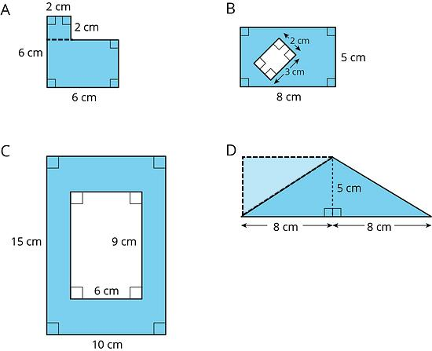

Main Classification of Problem-Simplifying Rearrangement
# Source: AI Source: Provided by: [Data Path: Persons Table -> ID Column: 1, Name_En Column: Motasem Essam] -> From: [ChatGPT] on [7/25/2026]
The following is a practical classification based on how rearrangement simplifies a problem. These categories can overlap and are not a universally standardized mathematical taxonomy.

1. Shape-Simplifying Rearrangement
# Source: AI Source: Provided by: [Data Path: Persons Table -> ID Column: 1, Name_En Column: Motasem Essam] -> From: [ChatGPT] on [7/25/2026]
Pieces are rearranged to create a familiar geometric shape whose properties or formulas are easier to use.
Example: An irregular polygon is rearranged into a rectangle so its area can be calculated using $A=lw$.
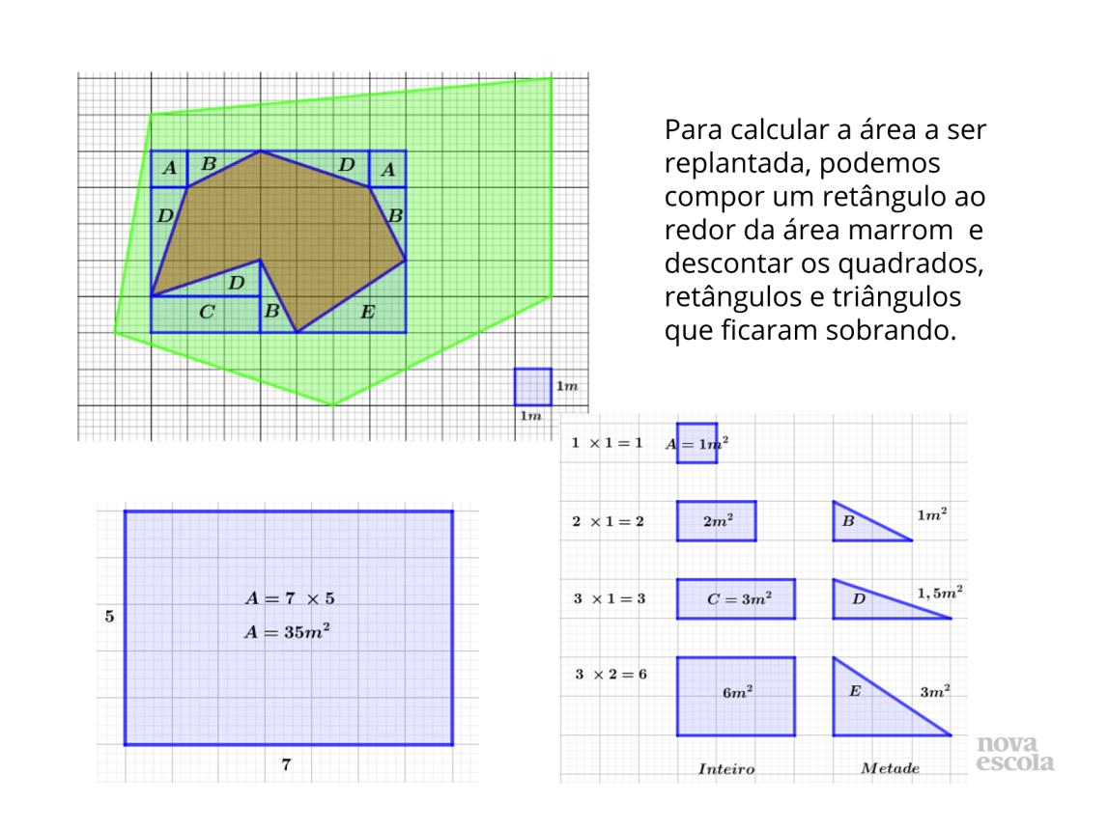

2. Area-Calculation-Simplifying Rearrangement
# Source: AI Source: Provided by: [Data Path: Persons Table -> ID Column: 1, Name_En Column: Motasem Essam] -> From: [ChatGPT] on [7/25/2026]
A composite figure is reorganized to make its total area easier to calculate, often by forming rectangles, triangles, or parallelograms.
Example: An L-shaped region is divided and rearranged into a rectangle, allowing its area to be calculated using $A=lw$.
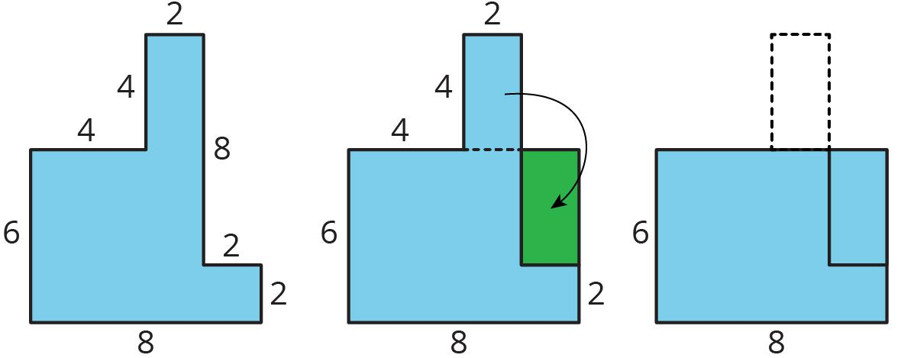

3. Symmetry-Revealing Rearrangement
# Source: AI Source: Provided by: [Data Path: Persons Table -> ID Column: 1, Name_En Column: Motasem Essam] -> From: [ChatGPT] on [7/25/2026]
Pieces are rearranged to reveal a line of symmetry, rotational symmetry, or another useful symmetric relationship.
Example: Two matching triangular pieces are positioned on opposite sides of a line to reveal the symmetry of the resulting figure.
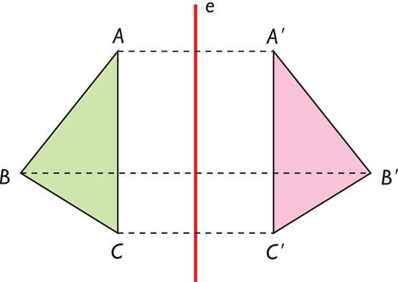

4. Relationship-Revealing Rearrangement
# Source: AI Source: Provided by: [Data Path: Persons Table -> ID Column: 1, Name_En Column: Motasem Essam] -> From: [ChatGPT] on [7/25/2026]
Pieces are rearranged to make a geometric relationship more visible, such as equal areas, corresponding lengths, or complementary regions.
Example: Triangular regions are rearranged to demonstrate that two different polygons have equal areas.
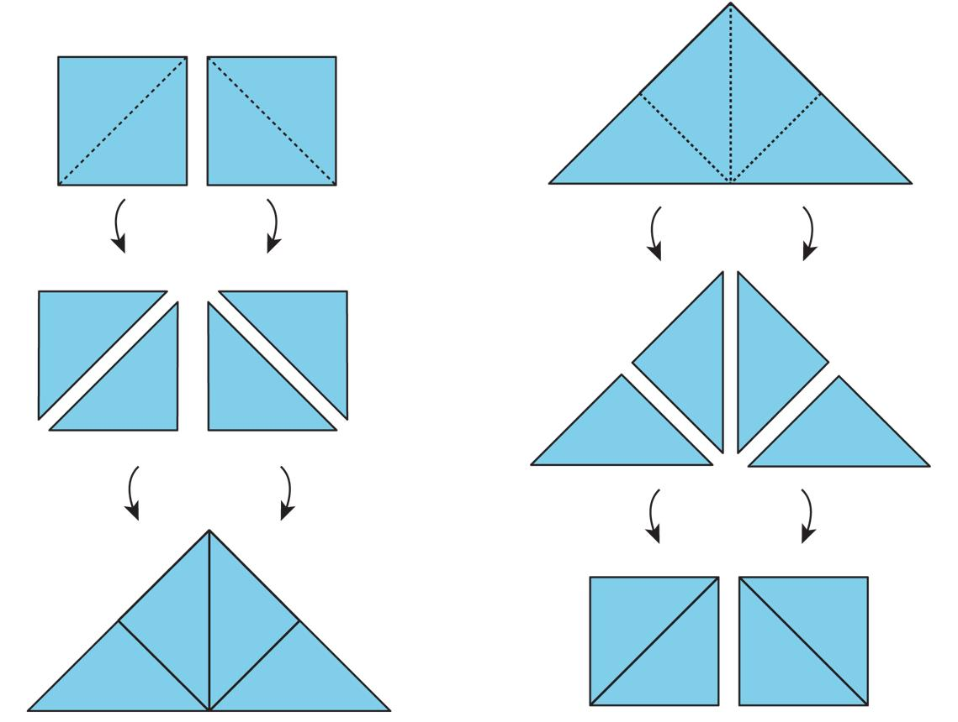

5. Formula-Based Rearrangement
# Source: AI Source: Provided by: [Data Path: Persons Table -> ID Column: 1, Name_En Column: Motasem Essam] -> From: [ChatGPT] on [7/25/2026]
A figure is rearranged to match a standard geometric formula or to provide a visual derivation of that formula.
Example: A parallelogram is cut and rearranged into a rectangle, demonstrating why its area is $A=bh$.
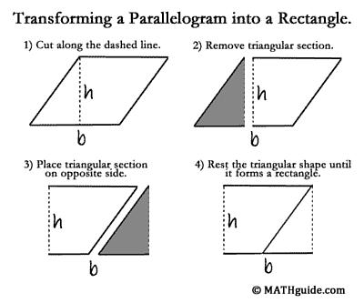

6. Calculation-Reduction Rearrangement
# Source: AI Source: Provided by: [Data Path: Persons Table -> ID Column: 1, Name_En Column: Motasem Essam] -> From: [ChatGPT] on [7/25/2026]
A figure is rearranged to reduce the number of separate calculations needed.
Example: Several rectangular regions are combined into one larger rectangle, allowing the total area to be found with a single multiplication instead of several additions.
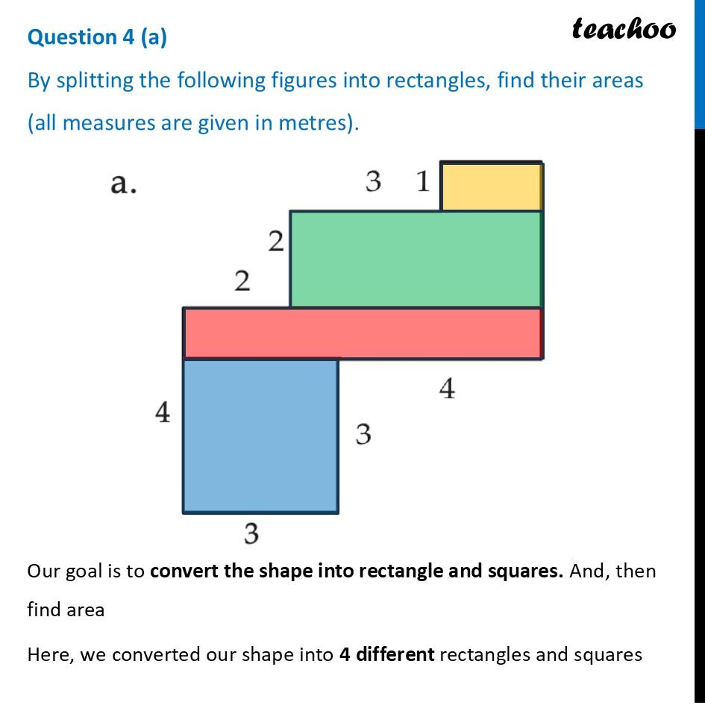

7. Complementary-Region Rearrangement
# Source: AI Source: Provided by: [Data Path: Persons Table -> ID Column: 1, Name_En Column: Motasem Essam] -> From: [ChatGPT] on [7/25/2026]
A figure is reorganized to make use of a complement, such as finding the area of a large shape and subtracting an unwanted region.
Example: A polygon with a rectangular notch is treated as a complete rectangle minus the missing rectangular region.
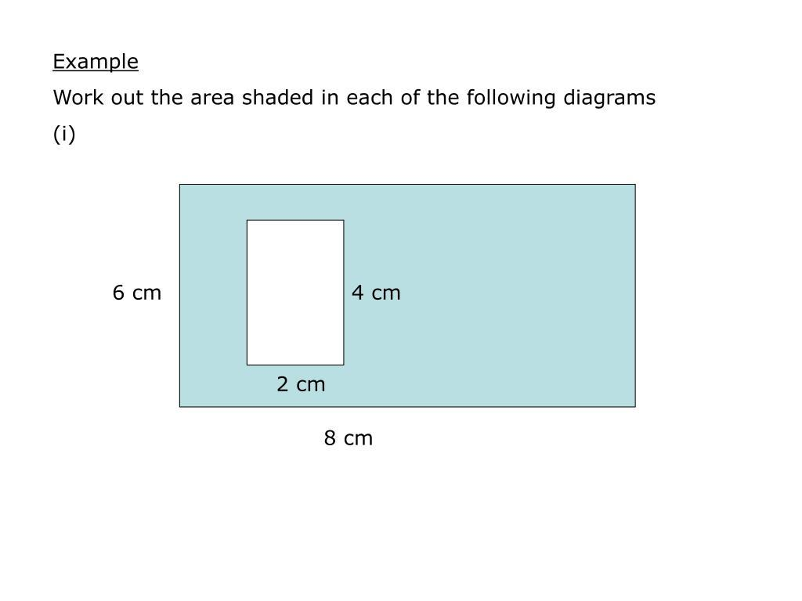

8. Proof-Simplifying Rearrangement
# Source: AI Source: Provided by: [Data Path: Persons Table -> ID Column: 1, Name_En Column: Motasem Essam] -> From: [ChatGPT] on [7/25/2026]
Pieces are rearranged to make a geometric statement easier to demonstrate or prove.
Example: Triangular pieces are repositioned to show that the area of a triangle is half the area of a parallelogram with the same base and height.
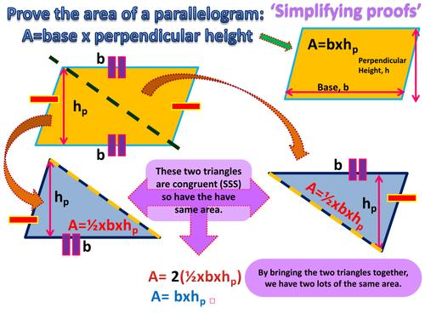

Mathematical Principle
# Source: AI Source: Provided by: [Data Path: Persons Table -> ID Column: 1, Name_En Column: Motasem Essam] -> From: [ChatGPT] on [7/25/2026]
Suppose a figure $F$ consists of pieces $P_{1},P_{2},…,P_{n}$. A rearrangement produces a new figure $G$:
$$F=\bigcup_{i=1}^{n}{P_{i}}$$
$$G=\bigcup_{i=1}^{n}{P_{i}}'$$
When the pieces are moved using area-preserving transformations and assembled without gaps or overlapping interiors,
$$\boxed{A\left(F\right)=A\left(G\right)}$$
The key advantage is that $G$ may have a simpler structure than $F$, making its area or other properties easier to determine.
However, not every problem-simplifying rearrangement must preserve area. If the rearrangement changes the figure's scale or uses a different representation, the relevant quantity must be tracked separately.

Detailed Mathematical Example
# Source: AI Source: Provided by: [Data Path: Persons Table -> ID Column: 1, Name_En Column: Motasem Essam] -> From: [ChatGPT] on [7/25/2026]
Consider an L-shaped region formed by two non-overlapping rectangles:
- Rectangle 1: $8×2$ units.
- Rectangle 2: $3×4$ units.
Their total area is
$$A_{1}=8\left(2\right)=16$$
$$A_{2}=3\left(4\right)=12$$
Therefore,
$$A_{\text{total}}=16+12=28$$
If the same region can be dissected and rearranged into a rectangle, the resulting rectangle must have area
$$\boxed{A_{\text{rectangle}}=28}$$
The rearrangement can simplify the visual structure, but the dimensions of the resulting rectangle must still be established. Equal area alone does not guarantee that the pieces can form a rectangle of any arbitrarily chosen dimensions.

Properties of Problem-Simplifying Rearrangement
# Source: AI Source: Provided by: [Data Path: Persons Table -> ID Column: 1, Name_En Column: Motasem Essam] -> From: [ChatGPT] on [7/25/2026]
- Simplification: Makes a figure or calculation easier to analyze.
- Structure recognition: Reveals familiar shapes and geometric relationships.
- Formula accessibility: Allows standard area, perimeter, or length formulas to be applied.
- Reduced computation: May decrease the number of calculations required.
- Visual clarity: Makes hidden relationships easier to recognize.
- Proof support: Can provide a visual argument for geometric identities and theorems.
- Transformation flexibility: May use translation, rotation, reflection, dissection, or combinations of these operations.
- Quantity awareness: Any quantity claimed to be preserved must be verified under the operations used.

Problem-Simplifying Rearrangement vs. Other Types
# Source: AI Source: Provided by: [Data Path: Persons Table -> ID Column: 1, Name_En Column: Motasem Essam] -> From: [ChatGPT] on [7/25/2026]
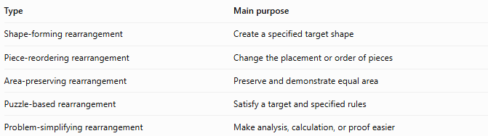
Type | Main purpose
Shape-forming rearrangement | Create a specified target shape
Piece-reordering rearrangement | Change the placement or order of pieces
Area-preserving rearrangement | Preserve and demonstrate equal area
Puzzle-based rearrangement | Satisfy a target and specified rules
Problem-simplifying rearrangement | Make analysis, calculation, or proof easier
Important distinction: These categories overlap. For example, rearranging an L-shaped figure into a rectangle can be shape-forming, area-preserving, and problem-simplifying at the same time.

Classification Summary
# Source: AI Source: Provided by: [Data Path: Persons Table -> ID Column: 1, Name_En Column: Motasem Essam] -> From: [ChatGPT] on [7/25/2026]
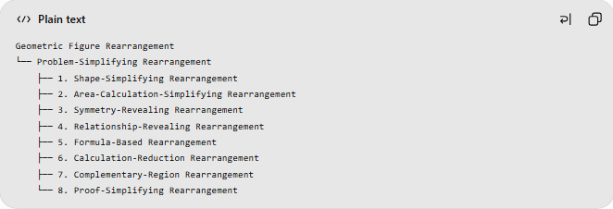
Geometric Figure Rearrangement
└── Problem-Simplifying Rearrangement
├── 1. Shape-Simplifying Rearrangement
├── 2. Area-Calculation-Simplifying Rearrangement
├── 3. Symmetry-Revealing Rearrangement
├── 4. Relationship-Revealing Rearrangement
├── 5. Formula-Based Rearrangement
├── 6. Calculation-Reduction Rearrangement
├── 7. Complementary-Region Rearrangement
└── 8. Proof-Simplifying Rearrangement
These are practical descriptive categories rather than mutually exclusive or universally standardized mathematical classes.

Key Points
# Source: AI Source: Provided by: [Data Path: Persons Table -> ID Column: 1, Name_En Column: Motasem Essam] -> From: [ChatGPT] on [7/25/2026]
- Problem-simplifying rearrangement focuses on making a geometric problem easier.
- It can reveal familiar shapes, symmetry, equal-area relationships, or useful formulas.
- It may simplify calculations or provide a clearer geometric proof.
- Area is preserved when the same pieces undergo area-preserving transformations and are assembled exactly.
- One rearrangement can belong to several descriptive categories simultaneously.

Conclusion
# Source: AI Source: Provided by: [Data Path: Persons Table -> ID Column: 1, Name_En Column: Motasem Essam] -> From: [ChatGPT] on [7/25/2026]
Problem-Simplifying Rearrangement is a geometric strategy that reorganizes a figure to make its properties easier to recognize and its problems easier to solve. Its main purpose is not simply to create a new shape, but to reveal a useful structure that leads to a clearer calculation or proof.

